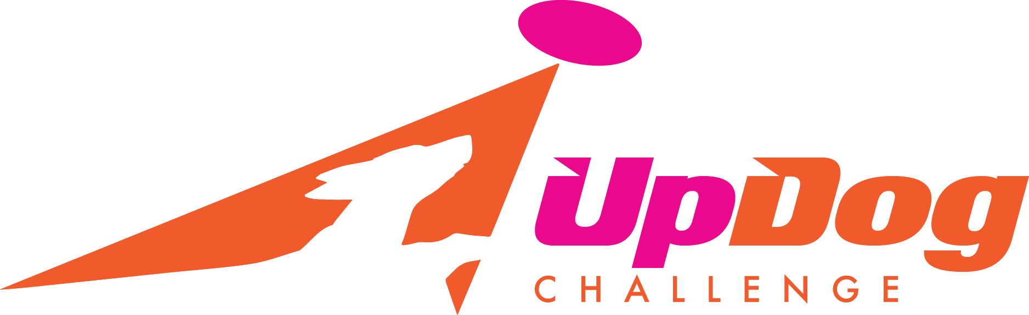
UpDog Challenge

Games (Level 1 Only):

- Freestyle (1 Round)
- 4Way Play
- Throw & Go
- Frizgility

For Freestyle – we will be offering both Level 1 and Level 2 freestyle. We will not be breaking each level into Height divisions. Note: We will only be holding the “Criterion Round” of freestyle (with the 2 bonus throws). We will not hold the “Performance Round”.

There are two levels of UpDog freestyle: Level 1 and Level 2. Level 1 is the recreational level. Level 2 if the advanced level. Unlike most other UpDog games, a team may choose which level of freestyle they would like to enter. (Teams do not have to earn their way to Level 2 through achievements and Ups.) The general rules for each level are the same, although the judging criteria for the criterion round is more sophisticated and at a higher degree of difficulty at level 2.

For Frizgility - you need to identify the division you are competing in: Mini, Midi, Maxi, Mega:

- Mini Division: Under 15” – Can opt to jump 4”, 8”, 12” or 16”

- Midi Division: 15”-18” – Can opt to jump 8”, 12”, 16” or 20”.

- Maxi Division: Over 18" – Can opt to jump 12”, 16”, 20” or 24"

- Mega Division: 23” and over – Can opt to jump 12”, 16”, 20” or 24"

There are no Mad-Dog Division awards for these games.

For complete rules and information on UpDog please visit their website: www.updogchallenge.com

Updog Team Number: If you have not yet registered for an Updog team number, it is recommended that you do so. By registering as a team (handler/dog) you can track all your accomplishments in Updog. If you ACTIVATE your team (just $5 per team), you are eligible to earn points towards Updog International Final qualification as well as receiving Ups/Achievements.
Go to: www.updogchallenge.com for more information on creating and activating a team.

Check# ______ Amount________
Cash Amount________
Square ________

UpDog Challenge
Hosted by MAD Dogs
Sunday, May 13, 2018

Handler Name:
Address:
City: |  |  |  |  | State: |  |  |  |  | Zip Code:
Phone: |  |  |  |  | Email:
Are you a MAD Dog Member? (Check one) |  |  | Yes |  |  | No | Club Affiliation:

 | Dog Name | Height | Mad Dog Member Fees by Game |  |  |  | Non Mad-Dog Member Fees by Game |  |  |  |  | Total Fee
 | Dog Name | Height | Freestyle | 4Way Play | Throw& Go | Frizgility | Freestyle | 4Way Play | Throw& Go |  | Frizgility
1 |  |  | $10 | $5 | $5 | $5 | $15 | $10 | $10 | $10
2 |  |  | $10 | $5 | $5 | $5 | $15 | $10 | $10 | $10
3 |  |  | $10 | $5 | $5 | $5 | $15 | $10 | $10 | $10
4 |  |  | $10 | $5 | $5 | $5 | $15 | $10 | $10 | $10
5 |  |  | $10 | $5 | $5 | $5 | $15 | $10 | $10 | $10
Grand Total

# | UpDog Challenge Games | Mark Here if playing this game | UpDog Level | UpDog Division | UpDog Jump Height
1 | Throw & Go |  | Level 1
1 | 4Way Play |  | Level 1
1 | Freestyle (Choose a level) |  | Level 1 Level 2
1 | Frizgility |  | Level 1 | Mini Midi Maxi Mega | 4 8 12 16 20 24
2 | Throw & Go |  | Level 1
2 | 4Way Play |  | Level 1
2 | Freestyle (Choose a level) |  | Level 1 Level 2
2 | Frizgility |  | Level 1 | Mini Midi Maxi Mega | 4 8 12 16 20 24
3 | Throw & Go |  | Level 1
3 | 4Way Play |  | Level 1
3 | Freestyle (Choose a level) |  | Level 1 Level 2
3 | Frizgility |  | Level 1 | Mini Midi Maxi Mega | 4 8 12 16 20 24
4 | Throw & Go |  | Level 1
4 | 4Way Play |  | Level 1
4 | Freestyle (Choose a level) |  | Level 1 Level 2
4 | Frizgility |  | Level 1 | Mini Midi Maxi Mega | 4 8 12 16 20 24
5 | Throw & Go |  | Level 1
5 | 4Way Play |  | Level 1
5 | Freestyle (Choose a level) |  | Level 1 Level 2
5 | Frizgility |  | Level 1 | Mini Midi Maxi Mega | 4 8 12 16 20 24

Release and Waiver of Liability
For and in consideration of my participation in the, UpDog Challenge, and Mid Atlantic Disc Dogs event, and for other good and valuable consideration, the receipt and sufficiency of which are hereby acknowledged, I the undersigned, intending to be legally bound do hereby for myself, my heirs, assigns, executors and administrators, waive and release any and all rights and claims for damages or injuries arising out of, or in any way related to, my participation in the Event, which I may have against the following parties: UpDog Challenge, and MAD Dogs, the administration and owner of the facility hosting the Event; together with the contractor, agents, employees and representatives of each of them. I certify that my canine and I are healthy and fit to compete in the Event.
I hereby grant to, UpDog Challenge, and MAD Dogs the exclusive right to record, broadcast, photograph, film and videotape my performances and related interviews at the Event and to utilize such recordings, broadcasts, photographs, films or videotapes together with my name, image, likeness, voice, and biographical information, for such publicity, promotional or commercial purposes as they may desire. I understand that, UpDog Challenge, and MAD Dogs may assign the right to use the recordings, broadcasts, images, photographs, film and videotape of my performance(s) together with my name, image, likeness, voice and biographical information to such person or other entity (including, but not limited to a television broadcaster) as they may desire without my further consent or knowledge and I expressly agree to such assignment.

Signature of |  | Parent or Guardian
Competitor |  | Signature (under 18)
 | Date |  | Date

