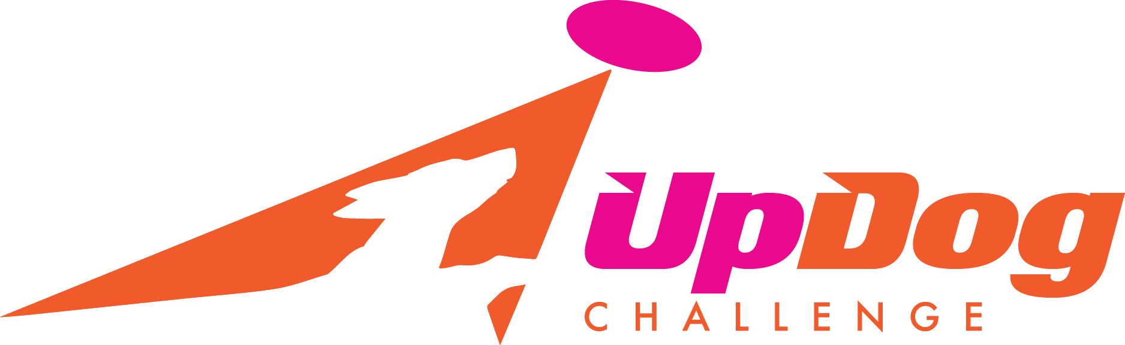
UpDog Challenge – Delaware
Sunday May 14, 2017
Registration 8:30 am Start Time 9:00 AM
Governor Bacon Health Center Parade Field (Fort DuPont)
248 Kent Ave, Delaware City, Delaware 19706
Games:
- Freestyle (1 round)
- Far Out (Updog’s Extreme Distance game)
- Throw & Go
- 4 Way Play

For Freestyle – we will be offering both Level 1 and Level 2 freestyle. We will not be breaking each level into Height divisions. Note: We will only be holding the “Criterion Round” of freestyle (with the 2 bonus throws). We will not hold the “Performance Round”

There are two levels of UpDog freestyle: Level 1 and Level 2. Level 1 is the recreational level. Level 2 is the advanced level. Unlike most other UpDog games, a team may choose which level of freestyle they would like to enter. (Teams do not have to earn their way to Level 2 through achievements and Ups.) The general rules for each level are the same, although the judging criteria for the criterion round is more sophisticated and at a higher degree of difficulty at level 2.

There are no Mad-Dog Division awards for these games.

For complete rules and information on UpDog please visit their website www.updogchallenge.com

Any entry that is not received via email by the deadline of Sunday, May 7, 2016 will be considered late. All late entries will be charged a $20.00 per team fee, no exceptions. You can pay your entry fees the day of the event, however it is preferred that they are mailed in advance.

- Email pre-registration forms to Laura O’Neill: wickedfrenzy@verizon.net by Sunday, May 7, 2016 to avoid the late fee. If mailing payment, please send by Monday, May 8, 2017 to Laura O’Neill 28 Kelly Drive, Bear, DE 19701 Make checks payable to MADDogs.

- Thank you for adhering to these Rules; it makes a world of difference in organizing Registration Entries ahead of time.

Updog Team #: If you have not yet registered for an Updog team #, it is recommended that you do so. By registering as a team (handler/dog) you can track all your accomplishments in Updog. If you ACTIVATE your team (just $5 per team), you are eligible to earn points towards Updog International Final qualification as well as receiving Ups/Achievements.
Go to: https://teams.updogchallenge.com for more information on creating and activating a team

Check# ______ Amount________
Cash Amount________

UpDog Challenge - Delaware
May 14, 2017
Registration 8:30 am Start Time 9:00 AM
Governor Bacon Health Center Parade Field (Fort DuPont)
248 Kent Ave, Delaware City, Delaware 19706

Handler Name:
Address:
City: |  |  |  |  | State: |  |  |  |  | Zip Code:
Phone: |  |  |  |  | Email:
Are you a MAD Dog Member? (Check one) |  |  | Yes |  |  | No | Club Affiliation:

 | Dog Name | UD Team # | Mad Dog Member Fees by Game |  |  |  | Non Mad-Dog Member Fees by Game |  |  |  | Late Fee | Total Fee
 | Dog Name | UD Team # | Freestyle | Far Out | Throw & Go | 4 Way Play | Freestyle | Far Out | Throw & Go | 4 Way Play
1 |  |  | $10 | $5 | $5 | $5 | $15 | $10 | $10 | $10 | $20
2 |  |  | $10 | $5 | $5 | $5 | $15 | $10 | $10 | $10 | $20
3 |  |  | $10 | $5 | $5 | $5 | $15 | $10 | $10 | $10 | $20
4 |  |  | $10 | $5 | $5 | $5 | $15 | $10 | $10 | $10 | $20
Total

#  Please Complete & Email form to: Laura O’Neill – WickedFrenzy@verizon.net  Mail Check (payable to MadDogs) to 28 Kelly Drive, Bear DE 19701  Forms must be postmarked no later than May 7th, 2017 | UpDog Challenge Games | Mark Here if playing this game | UpDog Level
1 | Freestyle |  | Level 1 Level 2
1 | Far Out |  | Level 1
1 | Throw & Go |  | Level 1
1 | 4 Way Play |  | Level 1
2 | Freestyle |  | Level 1 Level 2
2 | Far Out |  | Level 1
2 | Throw & Go |  | Level 1
2 | 4 Way Play |  | Level 1
3 | Freestyle |  | Level 1 Level 2
3 | Far Out |  | Level 1
3 | Throw & Go |  | Level 1
3 | 4 Way Play |  | Level 1
4 | Freestyle |  | Level 1 Level 2
4 | Far Out |  | Level 1
4 | Throw & Go |  | Level 1
4 | 4 Way Play |  | Level 1

Release and Waiver of Liability
For and in consideration of my participation in the, Skyhoundz Hyperflite, and Mid Atlantic Disc Dogs event, and for other good and valuable consideration, the receipt and sufficiency of which are hereby acknowledged, I the undersigned, intending to be legally bound do hereby for myself, my heirs, assigns, executors and administrators, waive and release any and all rights and claims for damages or injuries arising out of, or in any way related to, my participation in the Event, which I may have against the following parties: Skyhoundz Hyperflite, and MAD Dogs, the administration and owner of the facility hosting the Event; together with the contractor, agents, employees and representatives of each of them. I certify that my canine and I are healthy and fit to compete in the Event.
I hereby grant to, Skyhoundz Hyperflite, and MAD Dogs the exclusive right to record, broadcast, photograph, film and videotape my performances and related interviews at the Event and to utilize such recordings, broadcasts, photographs, films or videotapes together with my name, image, likeness, voice, and biographical information, for such publicity, promotional or commercial purposes as they may desire. I understand that, Skyhoundz Hyperflite, and MAD Dogs may assign the right to use the recordings, broadcasts, images, photographs, film and videotape of my performance(s) together with my name, image, likeness, voice and biographical information to such person or other entity (including, but not limited to a television broadcaster) as they may desire without my further consent or knowledge and I expressly agree to such assignment.

Signature of |  | Parent or Guardian
Competitor |  | Signature (under 18)
 | Date |  | Date

