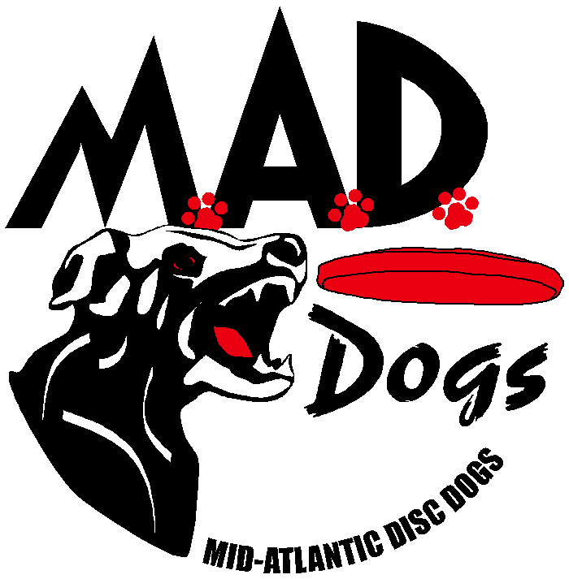

Hyperflite® skyhoundz®
Classic Qualifier
Saturday, May 31, 2014
Jim Dietrich Park
4899 Stoudts Ferry Road, Reading, PA 19605

PRE-REGISTRATION WITH PAYMENT IS
*REQUIRED* to Compete.
ABSOLUTELY NO EXCEPTIONS!

DUE: May 25, 2014

- NEW for 2014: Registration AND Payment must be received by deadline in order to participate in this event.

- Check payable to MAD Dogs

- Payments can also be made via Square Market https://squareup.com/market/mid-atlantic-disc-dogs-club-mad-dogs

- Mail Hyperflite Skyhoundz/MAD Dogs’ registration form & check to Melanie Griggs, 25230 Trunk Line Road, Henderson, MD 21640, Phone: 410-482-2636

- All entries are non-refundable* and required to be received by Sunday, May 25, 2014 (if mailed, receipt required by Saturday, May 24, 2014) … so mail it early.

- Pre-Registration forms and Payment is REQUIRED in order to compete. You can email the Registration to Melanie Griggs @ can.do.dogs@wildblue.net by Sunday, May 25, 2014.

- Cannot say it enough … payment must be received by the closing date in order to compete. Payment can be made either by check or Square Market at https://squareup.com/market/mid-atlantic-disc-dogs-club-mad-dogs NO EXCEPTIONS!!

Early Check- In (Packet Pickup & Check Entry for Accuracy)
- Friday, May 30, 6-8 pm
- Location: Awesome Dawgs, 3052 Pricetown Road, Temple, Pennsylvania 19560 - (610) 750-6868

See www.skyhoundz.com for more information.

*Refundable with either Vet or Doctor Certificate
Check# ______ Amount________
Cash Amount________
Hyperflite® skyhoundz®
Classic Qualifier
Saturday, May 31, 2014
PRE-REGISTRATION WITH PAYMENT IS
*REQUIRED* to Compete.
ABSOLUTELY NO EXCEPTIONS!
DUE: May 25, 2014
Jim Dietrich Park
4899 Stoudts Ferry Road, Reading, PA 19605
Day of Check-In 8:00 AM; Starts 9:00 AM

Handler:
Address:
City: |  |  | State: |  |  | Zip Code:
Phone: |  | Email Address:
Competition City: | Reading, PA | ONE Disc Dog Club Affiliation:

You can enter as many Events and Classes for which the team qualifies.
# | Dog Name | Breed | Weight | Height | Age | Sex | Member Fees | Non Member Fees | Total
1 |  |  |  |  |  |  | $25 | $30
2 |  |  |  |  |  |  | $20 | $25
3 |  |  |  |  |  |  | $15 | $20
4 |  |  |  |  |  |  | $10 | $15
Grand Total

# | Event** | Class***
# | Event** | Expert | Master | Novice | Youth* | Micro | Team | 2nd Handler for Pairs Freestyle
1 | Sport (D/A)
1 | Open (F/S)
1 | Pairs Freestyle
2 | Sport (D/A)
2 | Open (F/S)
2 | Pairs Freestyle
3 | Sport (D/A)
3 | Open (F/S)
3 | Pairs Freestyle
4 | Sport (D/A)
4 | Open (F/S)
4 | Pairs Freestyle
Release and Waiver of Liability
For and in consideration of my participation in the Hyperflite Skyhoundz / Mid Atlantic Disc Dogs event, and for other good and valuable consideration, the receipt and sufficiency of which are hereby acknowledged, I the undersigned, intending to be legally bound do hereby for myself, my heirs, assigns, executors and administrators, waive and release any and all rights and claims for damages or injuries arising out of, or in any way related to, my participation in the Event, which I may have against the following parties: Hyperflite Skyhoundz, Inc, MAD Dogs, Inc, the administration and owner of the facility hosting the Event; together with the contractor, agents, employees and representatives of each of them. I certify that my canine and I are healthy and fit to compete in the Event.
I hereby grant to Hyperflite Skyhoundz and MAD Dogs the exclusive right to record, broadcast, photograph, film and videotape my performances and related interviews at the Event and to utilize such recordings, broadcasts, photographs, films or videotapes together with my name, image, likeness, voice, and biographical information, for such publicity, promotional or commercial purposes as they may desire. I understand that Hyperflite Skyhoundz and MAD Dogs may assign the right to use the recordings, broadcasts, images, photographs, film and videotape of my performance(s) together with my name, image, likeness, voice and biographical information to such person or other entity (including, but not limited to a television broadcaster) as they may desire without my further consent or knowledge and I expressly agree to such assignment.

Signature of |  |  |  |  | Parent or Guardian
Competitor |  |  | Date |  | Signature (under 18) |  |  | Date

Additional Information

Hyperflite Skyhoundz® Classic US Open Qualifier Events/Classes Brief Descriptions:

NEW:
- Only height criteria used to determine the MicroDog Class, weight criteria was eliminated
- D/A (Sport) & F/S (Open) Expert Classes will each have 2 Qualifying spots for the World Championships
- Time will not stop for canine nature breaks

**Events:
Distance/Accuracy (D/A): (Classes: Expert, Master, Novice) A 60-second event using 1 disc. Points are awarded for catches made within one of the 4 scoring zones based on the most trailing paw (10-20, 20-30, 30-40, & 40-50 yd.). Points are 1, 2, 3, & 5 respectively with a bonus of a ½ pt for each catch made with all paws in the air.

Freestyle (F/S): (Classes: Expert, Master, MicroDog, Novice, Youth) Choreographed 90 second routine set to music, using up to 5 discs, performing a variety of tricks & maneuvers. This is judged using the Skyhoundz PAWS Scoring System with a maximum of 40 points or 10 points for each of the following four categories: Presentation, Athleticism, Wow Factor, and Success.

Pairs Freestyle (P/F): (Class: Expert) Choreographed 90 second routine set to music, using up to 10 discs, performing a variety of tricks & maneuvers. This is judged using the Skyhoundz PAWS Scoring System with a maximum of 50 points or 10 points for each of the following four categories: Presentation, Athleticism, Wow Factor, Success and Teamwork.

***Classes:
Expert: Anyone can enter, except a canine registered in the Expert Class may not simultaneously enter in the Masters Class. (Top two teams receive invitations to the World Championship)

Master: Master – Dogs 9 years and older (as of the date of the competition entered). A canine registered in the Masters Class may not simultaneously enter in the Expert Class.

MicroDog: Canine must be 16 or fewer inches tall as measured from the ground to a point midway between the front and back shoulders. (Top two teams receive invitations to the World Championship)

Novice - A team composed of a canine and thrower of which, either together or separately, have never finished higher than fourth place at any Hyperflite Skyhoundz Regional, Open or International Qualifier in any of the following Divisions: Open, Sport, MicroDog, or Pairs Freestyle.

Pairs Freestyle: Team can be any combination of throwers performing with one canine. (Top two teamss receive invitations to the World Championship)

*Youth: Competitors must be 15 years of age or younger as of December 31st of the year in which they are competing in the Youth Division. (Top two teams receive invitations to the World Championship)

