Check# ______ Amount________
Cash Amount________
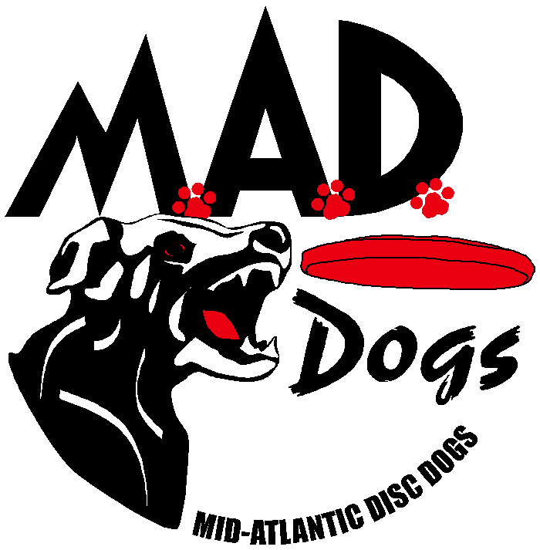

Hyperflite® skyhoundz®
Eastern Open Qualifier
Saturday, June 29, 2013
T.J. Davis Recreation Center
400 E. 6th St., Roanoke Rapids, NC 27870
Registration 7:45 AM; Starts 9:00 AM

Handler:
Address:
City: |  |  | State: |  |  | Zip Code:
Phone: |  | Email Address:
Competition City: | Roanoke Rapids, NC | ONE Disc Dog Club Affiliation:

You can enter as many Events and Classes for which the team qualifies.
# | Dog Name | Breed | Weight | Height | Age | Sex | Member Fees | Non Member Fees | Late Fees | Total
1 |  |  |  |  |  |  | $25 | $30 | $5
2 |  |  |  |  |  |  | $20 | $25 | $5
3 |  |  |  |  |  |  | $15 | $20 | $5
4 |  |  |  |  |  |  | $10 | $15 | $5
Grand Total

# | Event** | Class***
# | Event** | Expert | Master | Novice | Youth* | Micro | Team | 2nd Handler for Pairs Freestyle
1 | Sport (D/A)
1 | Open (F/S)
1 | Pairs Freestyle
2 | Sport (D/A)
2 | Open (F/S)
2 | Pairs Freestyle
3 | Sport (D/A)
3 | Open (F/S)
3 | Pairs Freestyle
4 | Sport (D/A)
4 | Open (F/S)
4 | Pairs Freestyle
Release and Waiver of Liability
For and in consideration of my participation in the Hyperflite Skyhoundz / Mid Atlantic Disc Dogs event, and for other good and valuable consideration, the receipt and sufficiency of which are hereby acknowledged, I the undersigned, intending to be legally bound do hereby for myself, my heirs, assigns, executors and administrators, waive and release any and all rights and claims for damages or injuries arising out of, or in any way related to, my participation in the Event, which I may have against the following parties: Hyperflite Skyhoundz, Inc, MAD Dogs, Inc, the administration and owner of the facility hosting the Event; together with the contractor, agents, employees and representatives of each of them. I certify that my canine and I are healthy and fit to compete in the Event.
I hereby grant to Hyperflite Skyhoundz and MAD Dogs the exclusive right to record, broadcast, photograph, film and videotape my performances and related interviews at the Event and to utilize such recordings, broadcasts, photographs, films or videotapes together with my name, image, likeness, voice, and biographical information, for such publicity, promotional or commercial purposes as they may desire. I understand that Hyperflite Skyhoundz and MAD Dogs may assign the right to use the recordings, broadcasts, images, photographs, film and videotape of my performance(s) together with my name, image, likeness, voice and biographical information to such person or other entity (including, but not limited to a television broadcaster) as they may desire without my further consent or knowledge and I expressly agree to such assignment.

Signature of |  |  |  |  | Parent or Guardian
Competitor |  |  | Date |  | Signature (under 18) |  |  | Date

Additional Information

Hyperflite Skyhoundz® Regional Events/Classes Brief Descriptions:
NEW:
- The *Youth Class now falls under the Freestyle Event ONLY as it is now a Qualifying Class. If they want to enter the Sport Event, they must do so under another class.
- D/A (Sport) & F/S (Open) Expert Classes will each have 3 Qualifying spots for the World Championships.

**Events:
Distance/Accuracy (D/A): (Classes: Expert, Master, Novice) A 60-second event using 1 disc. Points are awarded for catches made within one of the 4 scoring zones based on the most trailing paw (10-20, 20-30, 30-40, & 40-50 yd.). Points are 1, 2, 3, & 5 respectively with a bonus of a ½ pt for each catch made with all paws in the air.

Freestyle (F/S): (Classes: Expert, Master, MicroDog, Novice, Youth) Choreographed 90 second routine set to music, using up to 5 discs, performing a variety of tricks & maneuvers. This is judged using the Skyhoundz PAWS Scoring System with a maximum of 40 points or 10 points for each of the following four categories: Presentation, Athleticism, Wow Factor, and Success.

Pairs Freestyle (P/F): (Class: Expert) Choreographed 90 second routine set to music, using up to 10 discs, performing a variety of tricks & maneuvers. This is judged using the Skyhoundz PAWS Scoring System with a maximum of 50 points or 10 points for each of the following four categories: Presentation, Athleticism, Wow Factor, Success and Teamwork.

***Classes:
Expert: Anyone can enter, except a canine registered in the Expert Class may not simultaneously enter in the Masters Class. (Top three winners receive invitations to the World Championship)

Master: Master – Dogs 9 years and older (as of the date of the competition entered). A canine registered in the Masters Class may not simultaneously enter in the Expert Class.

MicroDog: Canine must weigh less than 25 pounds or be 16 or fewer inches tall as measured from the ground to a point midway between the front and back shoulders. (Top two winners receive invitations to the World Championship)

Novice - A team composed of a canine and thrower of which, either together or separately, have never finished higher than fourth place at any Hyperflite Skyhoundz Regional, Open or International Qualifier in any of the following Divisions: Open, Sport, MicroDog, or Pairs Freestyle.

Pairs Freestyle: Team can be any combination of throwers performing with one canine. (Top two winners receive invitations to the World Championship)

*Youth: Competitors must be 15 years of age or younger as of December 31st of the year in which they are competing in the Youth Division. (Top two winners receive invitations to the World Championship)

- Check payable to MAD Dogs
- Mail Hyperflite Skyhoundz/MAD Dogs’ registration form & check to Melanie Griggs
- Melanie’s Address: 25230 Trunk Line Road, Henderson, MD 21640, Phone: 410-482-2636
- All entries are non-refundable and required to be postmarked by Saturday, June 22, 2013.
- Email Pre-Registration forms to Melanie Griggs @ can.do.dogs@wildblue.net by Sunday, June 23, 2013 to avoid the late fee.
- Sign-in & Late Registration begins at 7:45 AM
- Late registration accepted (with applicable late fees) until 8:45 AM on the day of the event
See www.skyhoundz.com for more information.

