MAD DOGS YEAR END AWARDS BANQUET
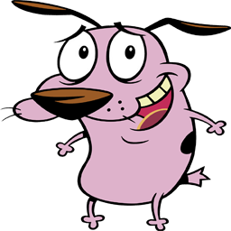
Saturday, March 10, 2018
6:30pm
Hellas Restaurant
8498 Veterans Highway
Millersville, MD 21108

Menu
Adults: Jumbo Lump Crab Cake
Steak
Lasagna
Children: Kids Burger
Chicken Tenders
Hot Dog and Fries
Spaghetti and Meatballs
Shrimp Basket
Grilled Cheese
Kids Pizza
Mozzarella Sticks

Cost: Members of 2017 – Free
Guests and Non Members:
Adults $25.00
Children $10.00
RSVP No Later than: Saturday March 3rd 2018

